**Check Drive Space**

## **Check Drive Space:**

## **How to Check Drive Space:**

**Create Drive Space script using PowerShell**

1. Open PowerShell IDE and paste below content(Code mention in step 1 only) into PowerShell.

Function Write-Log

{

[CmdletBinding()]

Param(

[Parameter(Mandatory=$False)]

[ValidateSet("INFO","WARN","ERROR","FATAL","DEBUG")]

[String]

$Level = "INFO",

[Parameter(Mandatory=$True)]

[string]

$Message,

[Parameter(Mandatory=$False)]

[string]

$logfile

)

$content = "[$Stamp] [$Level] $Message"

if($logfile)

{

Add-Content $logfile -Value $content

}

else

{

Write-Output $content

}

}

function Get-CurrentLineNumber

{

$MyInvocation.ScriptLineNumber

}

$ScriptDirectory = "C:\Share\"

$InstallerLogFileName="$ScriptDirectory\Specified_free_disk.log"

$disk = Get-WmiObject Win32_LogicalDisk -Filter "DeviceID='C:'" | Select-Object Size, FreeSpace

$specified_space = 50

$disk_space = ("{0}" -f [math]::truncate($disk.Size / 1GB))

$free_space = ("{0}" -f [math]::truncate($disk.FreeSpace / 1GB))

Write-Log "INFO" "[$(Get-CurrentLineNumber)] 'Total Disk Space: $disk_space' "$InstallerLogFileName""

Write-Log "INFO" "[$(Get-CurrentLineNumber)] 'Free Space in disk: $free_space' "$InstallerLogFileName""

Write-Log "INFO" "[$(Get-CurrentLineNumber)] 'Specified Free Disk: $specified_space' "$InstallerLogFileName""

$specified_space = $specified_space -as [int]

$disk_space = $disk_space -as [int]

if($specified_space -gt $free_space)

{

Write-Log "INFO" "[$(Get-CurrentLineNumber)] 'Spacified disk is greater than free space.' "$InstallerLogFileName""

}

elseif($specified_space -eq $free_space)

{

Write-Log "INFO" "[$(Get-CurrentLineNumber)] 'Spacified disk space is equal to disk space.' "$InstallerLogFileName""

}

else

{

Write-Log "INFO" "[$(Get-CurrentLineNumber)] 'Spacified disk is less than free space.' "$InstallerLogFileName""

} Function Write-Log

{

[CmdletBinding()]

Param(

[Parameter(Mandatory=$False)]

[ValidateSet("INFO","WARN","ERROR","FATAL","DEBUG")]

[String]

$Level = "INFO",

[Parameter(Mandatory=$True)]

[string]

$Message,

[Parameter(Mandatory=$False)]

[string]

$logfile

)

$content = "[$Stamp] [$Level] $Message"

if($logfile)

{

Add-Content $logfile -Value $content

}

else

{

Write-Output $content

}

}

function Get-CurrentLineNumber

{

$MyInvocation.ScriptLineNumber

}

$ScriptDirectory = "C:\Share\"

$InstallerLogFileName="$ScriptDirectory\Specified_free_disk.log"

$disk = Get-WmiObject Win32_LogicalDisk -Filter "DeviceID='C:'" | Select-Object Size, FreeSpace

$specified_space = 50

$disk_space = ("{0}" -f [math]::truncate($disk.Size / 1GB))

$free_space = ("{0}" -f [math]::truncate($disk.FreeSpace / 1GB))

Write-Log "INFO" "[$(Get-CurrentLineNumber)] 'Total Disk Space: $disk_space' "$InstallerLogFileName""

Write-Log "INFO" "[$(Get-CurrentLineNumber)] 'Free Space in disk: $free_space' "$InstallerLogFileName""

Write-Log "INFO" "[$(Get-CurrentLineNumber)] 'Specified Free Disk: $specified_space' "$InstallerLogFileName""

$specified_space = $specified_space -as [int]

$disk_space = $disk_space -as [int]

if($specified_space -gt $free_space)

{

Write-Log "INFO" "[$(Get-CurrentLineNumber)] 'Spacified disk is greater than free space.' "$InstallerLogFileName""

}

elseif($specified_space -eq $free_space)

{

Write-Log "INFO" "[$(Get-CurrentLineNumber)] 'Spacified disk space is equal to disk space.' "$InstallerLogFileName""

}

else

{

Write-Log "INFO" "[$(Get-CurrentLineNumber)] 'Spacified disk is less than free space.' "$InstallerLogFileName""

}

2. Save the script with name the ‘Check_Disk_Space.ps1’

**Check Drive Space using Manual**

* Open File Explorer.
* On left hand side click on This PC.

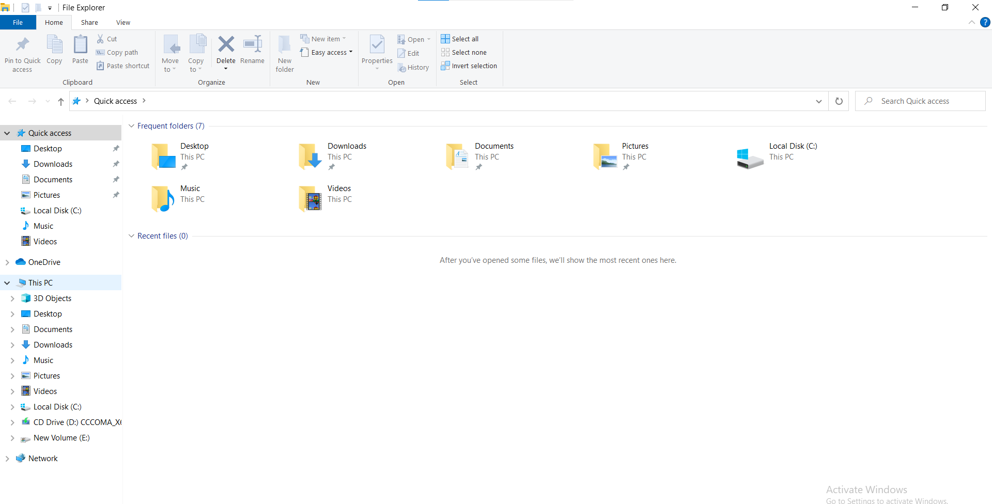

**Fig.2.1:** On File Explorer, This PC on left hand side.

* Select the drive for which you have to check free and occupied space.
* Right click on the drive, popup box will appear.
* At the end of popup box click on properties.

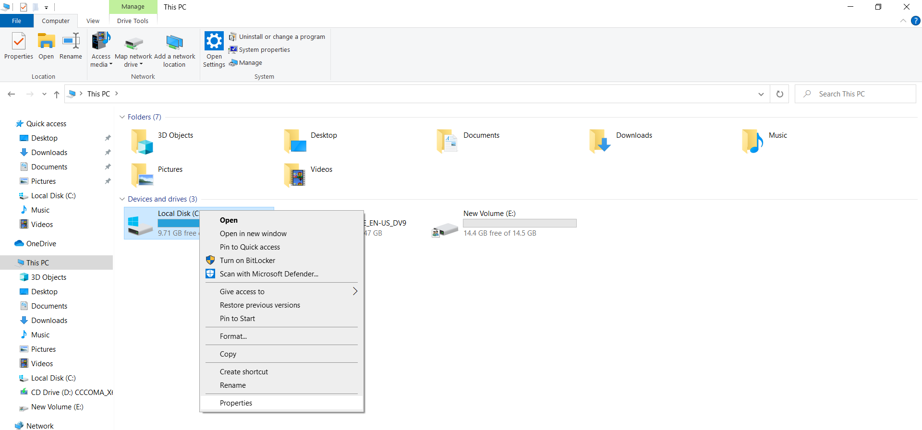

**Fig. 2.2:** After Selecting and right click on drive popup box for properties.

* Properties window will appear with General window.
* We can see the Used space, Free space of the drive with the capacity of drive.

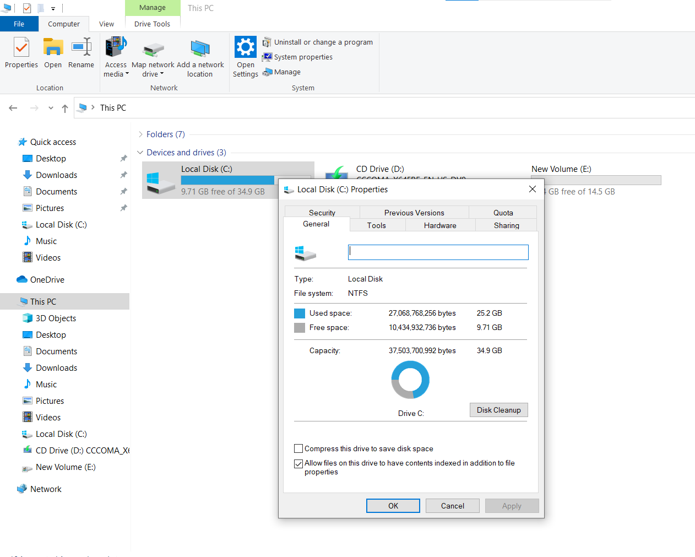

**Fig.2.3:** After clicking on properties window of General, displaying Used, Free space with the capacity of drive.

## **Evidence:**

* Local Execution with Evidence
* Check_Disk_Space.ps1 script must be in "C:\ Drive".
* Open PowerShell.
* Execute below command.

**Command:**

C:\Check_Disk_Space.ps1

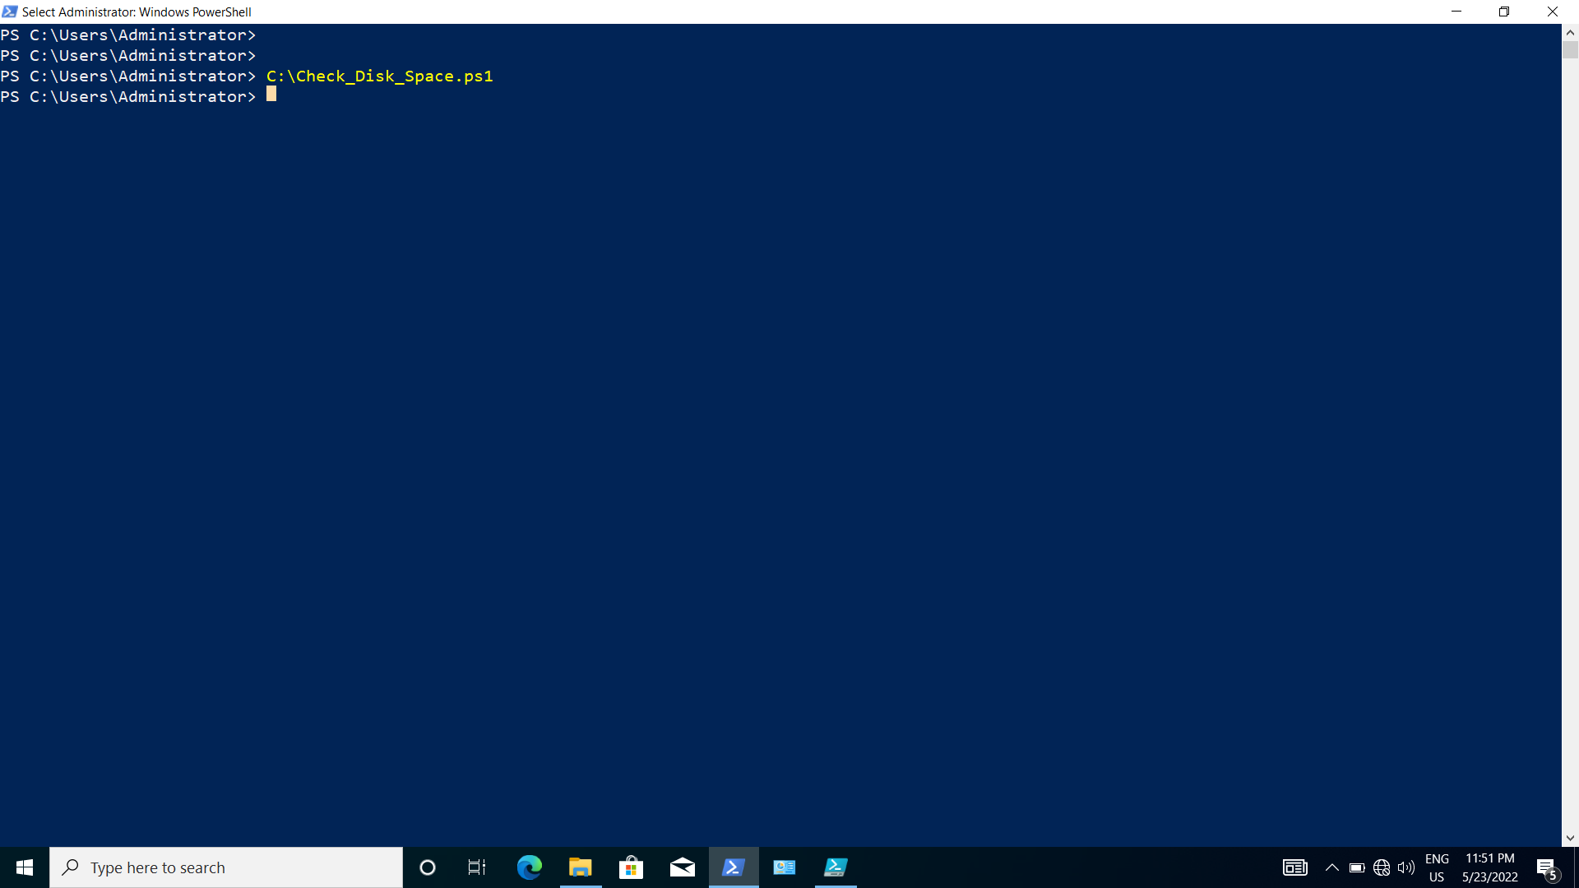

**Fig. 2.4:** Execution of Command on PowerShell

* Remote Execution with Evidence

Below command executed on MD system

**Command:**

python

import winrm

s = winrm.Session(‘<target_machine_ip>’, auth=(‘<user_name>’,’<password>’))

r = s.run_ps(‘C:\\Check_Disk_Space.ps1 ’)

r.status_code

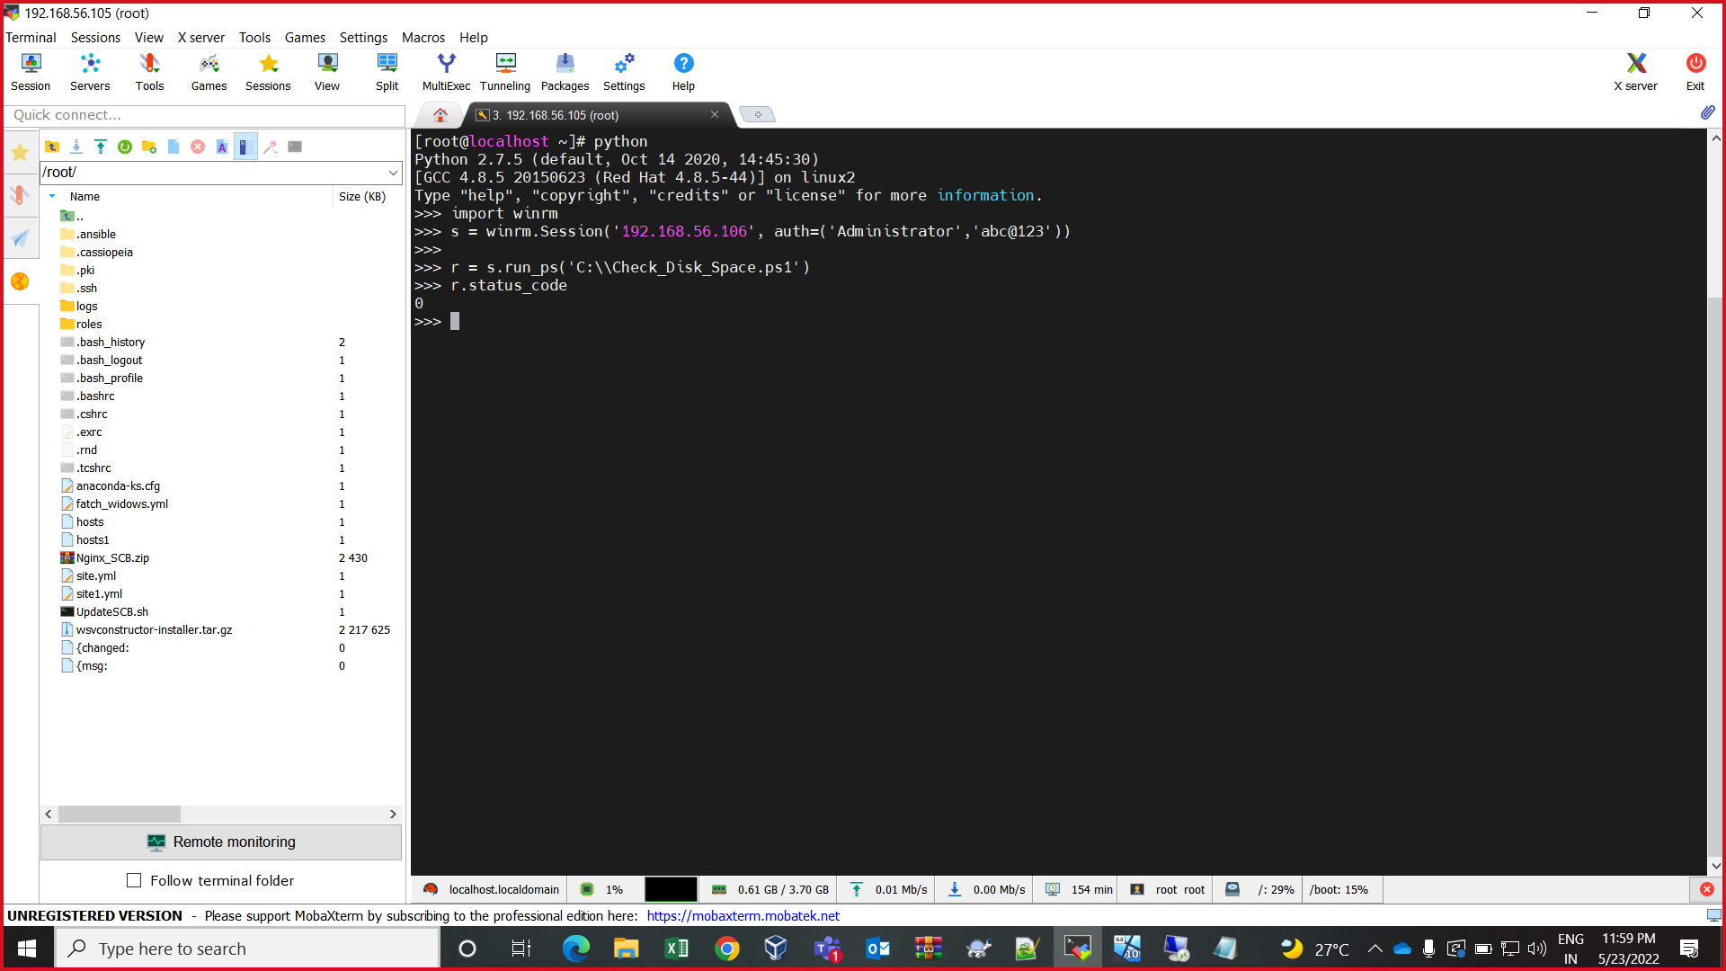

**Fig. 2.5:** Remote Execution on MD System Successful status evidence

## **Verification:**

* Login TS system.
* Open This PC.
* Go into local disk (C)
* Go into Share folder
* “Specified_Disk_Space.log” file must be there.

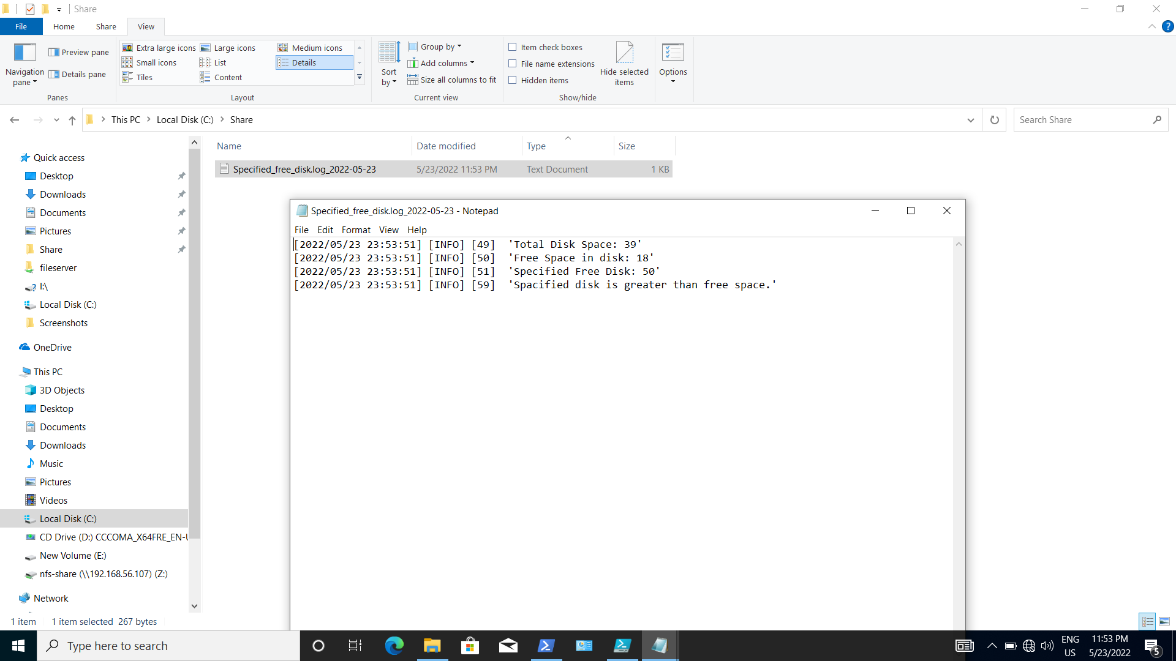

**Fig 2.6** DiskSpaceInfo.txt created on TS system after remote execution on MD System Successful